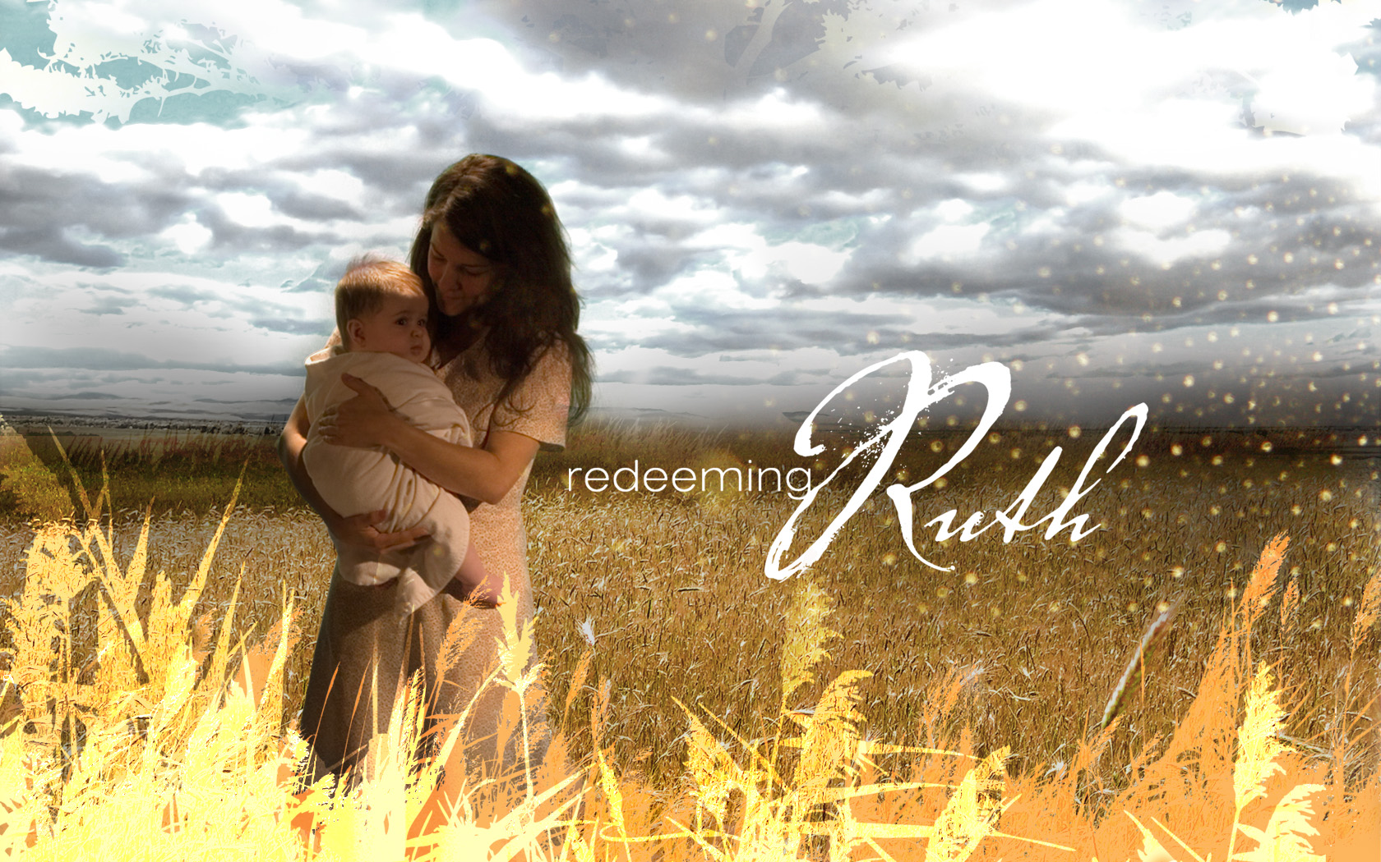

Redeeming Ruth

Part 4

“Where dreams can come true”

Ruth 2:1-3

- Dreams can come true amidst the problems and circumstances of life. (1)

Naomi and Ruth found themselves with no:

- Food

- Friends

- Favor

- Dreams can come true because of God’s providence not chance. (3)

The providence of God involves:

- His commands in the past.

- His control in the present.

- Dreams can come true with the help from people who are Christ-like. (1, 3)

Boaz was:

- Related to Naomi.

- A man of resources.

- A man of respect.

June 3, 2007 Redeeming Ruth
Tim Badal Copyrighted © 2007 Part 4

Redeeming Ruth

Part 4

“Where dreams can come true”

Ruth 2:1-3

- Dreams can come true amidst the problems and circumstances of life. (1)

Naomi and Ruth found themselves with no:

- Food

- Friends

- Favor

2. Dreams can come true because of God’s providence not chance. (3)

The providence of God involves:

- His commands in the past.

- His control in the present.

3. Dreams can come true with the help from people who are Christ-like. (1, 3)

Boaz was:

- Related to Naomi.

- A man of resources.

- A man of respect.
June 3, 2007 Redeeming Ruth
Tim Badal Copyrighted © 2007 Part 4

