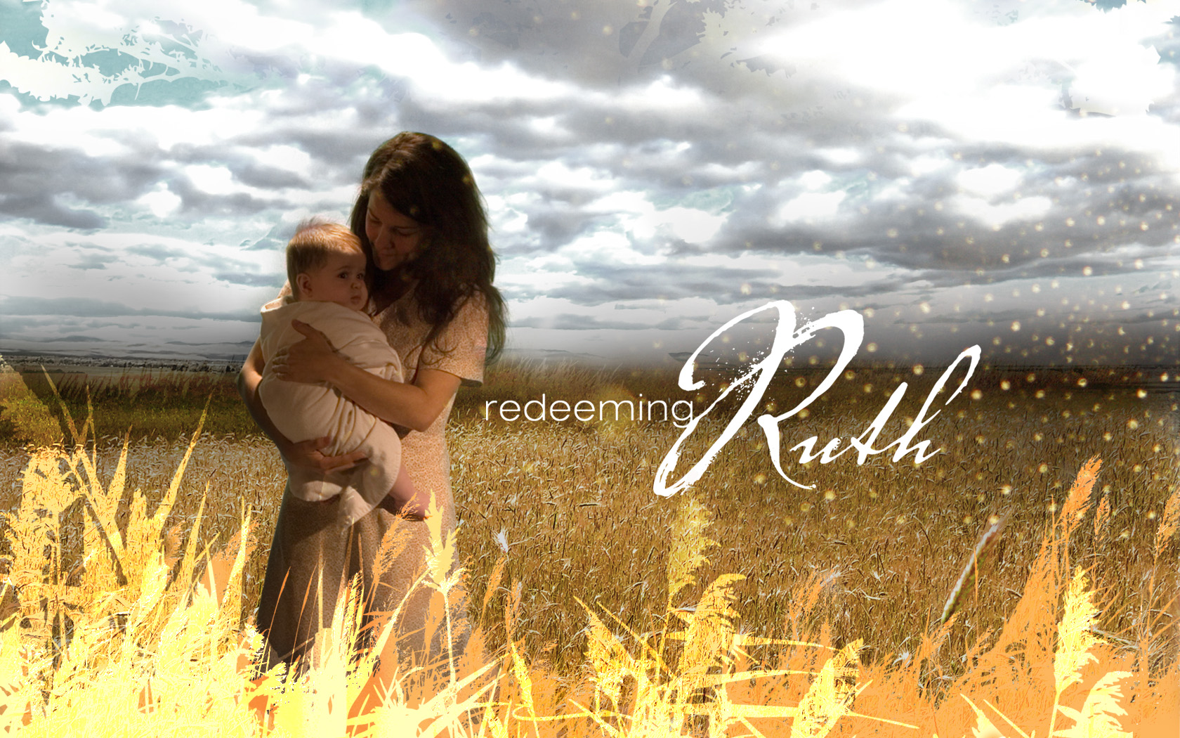
Redeeming Ruth

Part 5
“Field of Dreams”

Ruth 2:4-17

In God’s field of dreams we find:

- A place of acceptance.

This acceptance is seen in:

- God- honoring fellowship (4)
- The grace extended to foreigners (5-6a.)

- A place of access.

This access involves:

  - Direction (8)
  - Protection (9a.)
  - Satisfaction (9b.)
  - Communion (14)

- A place of amazement.

The grace of God:
- Should overwhelm us (10)
- It validates our obedience (11-12)
- Produces an outpouring (13)
- Allows for opportunity of service (14-16)


June 10, 2007 Redeeming Ruth
Tim Badal copyrighted © 2007 Part 5
Redeeming Ruth

Part 5
“Field of Dreams”

Ruth 2:4-17

In God’s field of dreams we find:

- A place of acceptance.

This acceptance is seen in:

- God- honoring fellowship (4)
- The grace extended to foreigners (5-6a.)

- A place of access.

This access involves:

  - Direction (8)
  - Protection (9a.)
  - Satisfaction (9b.)
  - Communion (14)

- A place of amazement.

The grace of God:
- Should overwhelm us (10)
- It validates our obedience (11-12)
- Produces an outpouring (13)
- Allows for opportunity of service (14-16)

June 10, 2007 Redeeming Ruth
Tim Badal copyrighted © 2007 Part 5

